Name of the media or free lance, city, web site..... | Kind of media (Radio, TV, newspaper, web, free lance) | Redaction  phone, e-mail  Representative of team  cell , e-mail | Media team *  Name, postion (journalist, camerman, photo, asistent...),
1.
2.
3.
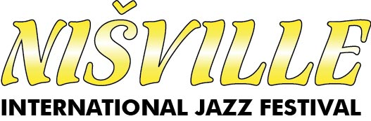
NIŠVILLE - JAZZ FESTIVAL

* TV - 3 acreditatons
* Radio, magazine, web - 2 acreditatons
* Free lance - 1 acreditaton
Filled form send at akreditacije@nisville.com

Short media plan (*REQUIRED)
NOTE: Nišville jazz festival reserves the right to use all photos published on the Internet free of charge.

